How to preserve file name of assets with the Asset Management System

Issue:
Asset Management System renames all files uploaded into the system with a unified naming system. This is problematic for certain types of assets such as software downloads where the explicit file name is provided in documentation, existing software, interfaces.

Resolution:
The following text documents the process for uploading assets in such a way that the original name of the file is preserved.

Actions:
Each MarCom Manager needs to determine which assets must maintain a predefined name – emphasis is on software downloads which TAC may be dealing with. Obtain original assets and upload according to the following documentation. The attached Excel sheet Lists the current software assets, titles, owners, etc.

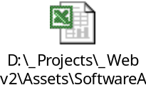

It will be important to revise the existing assets as opposed to deleting them and just starting fresh – this will preserve any links to the existing ID numbers that may be manually linked throughout the site.

Goal is to have this done in the next two weeks (if not sooner) so that we can minimize disruption with the support teams.

If you have any questions, please connect with Clint Gage – clinton.gage@flukenetworks.com
Action Key

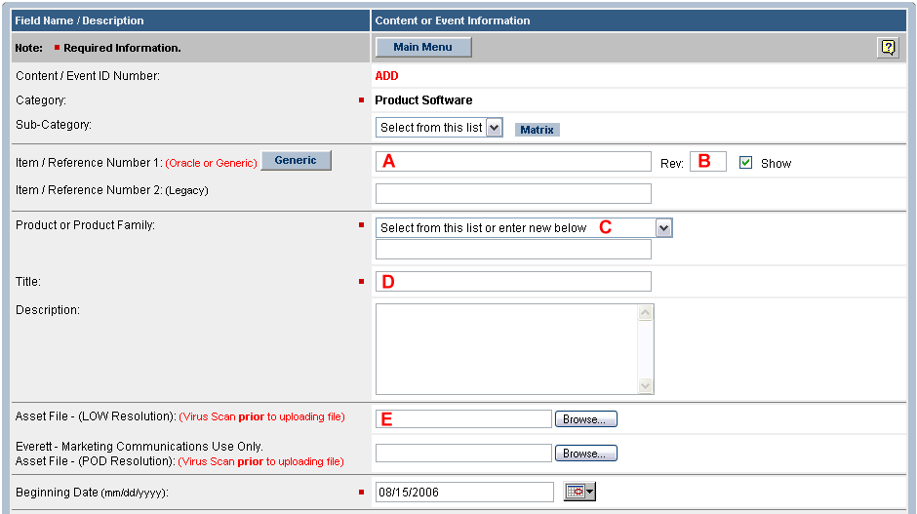
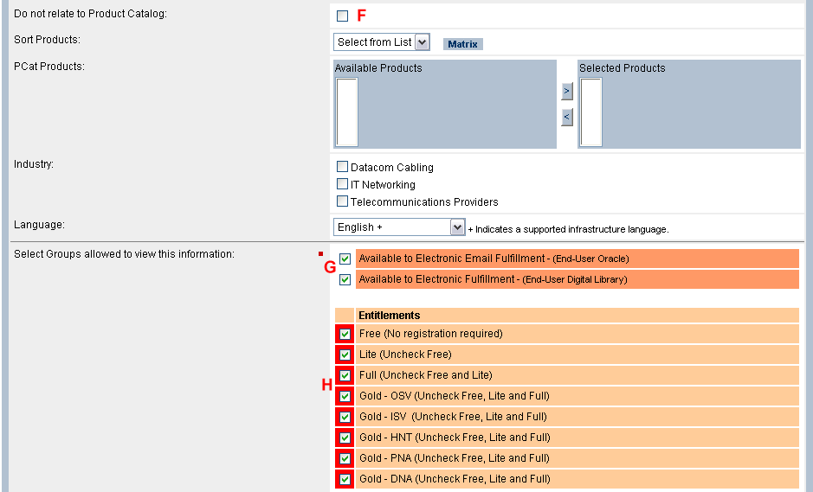

Adding new assets for the first time

Initiate a new asset entry after logging in.

- Do not enter Oracle Item or [Generic] Number into area A
- Don not enter revision letter into area B
- Complete Areas C, D and E
- Select F
- Unselect both checkboxes in area G
- Select or Unselect appropriate groups in area H
- Click on Save/Update

You are now on the edit screen.

- Inter Oracle Item or [Generic] Number in area A
- Enter revision code into area B
- Uncheck checkbox in area F
- Make PCAT relationships in area F
- Select Industry Code in area F
- Recheck both EEF and FDL checkboxes in area G
- Click on Save/Update

Remember you are in Review Status

- Click on the LIVE radio button at the top of the form
- Click on Save/Update
Revise an existing asset to reflect a fixed file name.

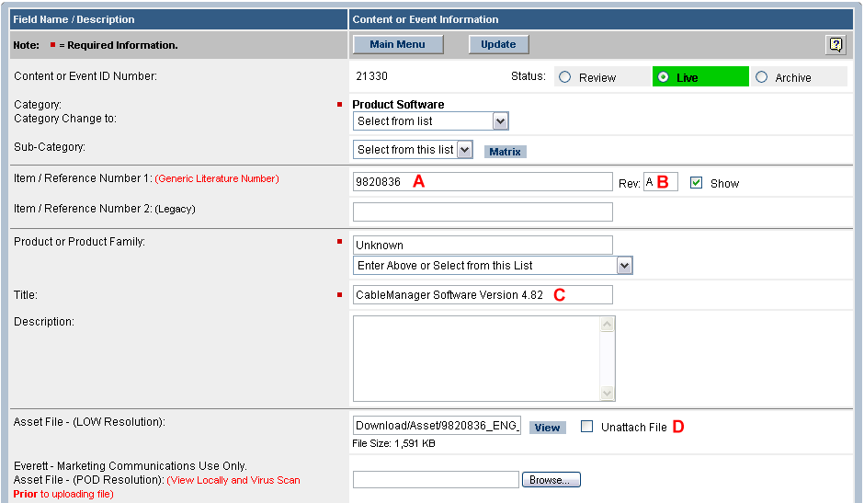
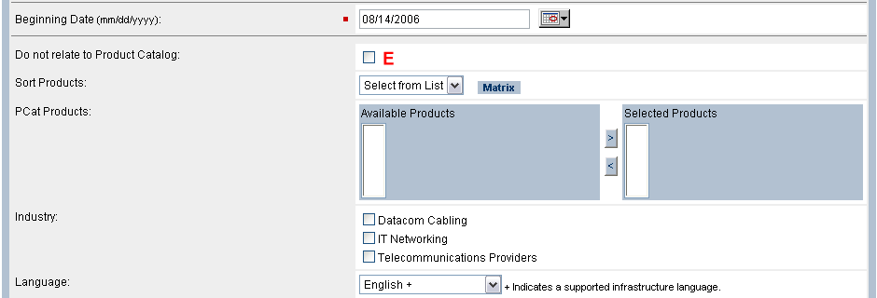
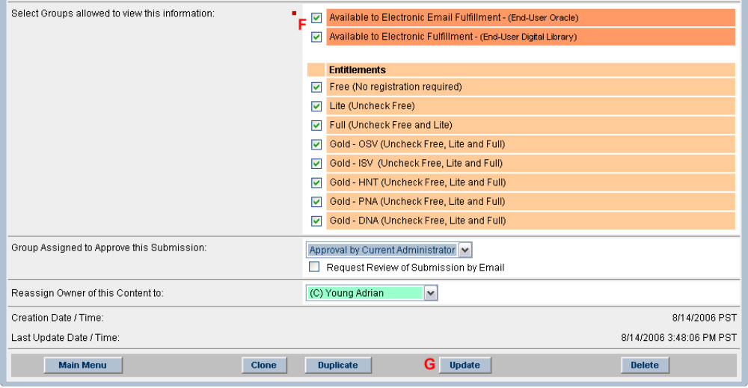

Select the asset that you want to modify

- Click “Unattach File” from area D
- Click on Update in area G

File has been unattached and [Browse] button returns.

- Copy Item Reference Number and Revision to Notepad (for cut and paste ability) from area A and B
- Copy Title to Notepad (for cut and paste ability) from area C
- Delete Item Reference Number from area A
- Browse for new file in area D
- Note PCAT relationship and Industry if applicable in area E so you can reapply in a moment
- Check “Do not relate to Product Catalog” in area E
- Uncheck EEF and FDL checkboxes in area F
- Click on Update in area G

Now to upload a New File and maintain the original file name

- Copy original Item Number and Revision into area A and B (From Notepad)
- Copy original Title into Area C (From Notepad)
- Uncheck “Do not relate to Product Catalog” in area E (if applicable)
- Set Language
- re-check EEF and FDL checkboxes in area F
- Click on Update in area G

This process is a work-around to retrofitting an existing asset when the file name needs to be retrained or the file updated.

